**SULIMO JOINT EXAM  
*Kenya Certificate of Secondary Education***

**231/1**

**BIOLOGY PAPER 1**

**(THEORY)**

**JULY 2024**

**TIME : 2 HOURS**

**Name**…………………………………………………..…… **Class**….………….……………….

**Candidate`s Signature**.…………………………………… **Date**…….…….……………………

Instructions to candidates

1. Write your name and index number in the spaces provided above.
2. Sign and write the date of the examination in the spaces provided above.
3. All questions are compulsory
4. Candidates should answer the questions in English.
5. This paper consists of 11 printed pages. Candidates should check the question paper to ascertain that all the pages are printed as indicated and that no questions are missing

***FOR EXAMINER’S USE ONLY****.*

|  |  |  |
| --- | --- | --- |
| **Question** | **Maximum Score** | **Candidate’s score** |
| **1 - 30** | **80** |  |

* 1. State the most suitable biological tool for collecting the following organisms:
     1. Grasshoppers (1 mark)

…………………………………………………………………………………………….

* + 1. Termites (1 mark)

…………………………………………………………………………………………….

* 1. Other than observation, name one other scientific skill developed by studying biology.

(1 mark)

………………………………………………………………………………………………

1. The table below shows the oxygen consumption and carbon (IV) oxide released at rest by a number of animals under certain conditions.

|  |  |  |  |  |
| --- | --- | --- | --- | --- |
| Animal | Body mass(g) | Carbon (IV) oxide released in cm3 per hour | Oxygen consumption in cm3 per hour | Respiratory Quotient |
| Mouse | 20 | 39 | 40 |  |
| Dog | 10000 | 1960 | 2800 |  |

* 1. Complete the table in the last column showing respiratory quotient. (2 marks)
  2. From the completed table above which animal was using the following respiratory substrates; (2 marks)
     1. Fat

…………………………………………………………………………………………….

* + 1. Glucose

…………………………………………………………………………………………….

* 1. State the type of circulatory system found in members of the class Insecta. (1 mark)

………………………………………………………………………………………………

* 1. Name the blood vessels that transport blood from: (2 marks)
     1. Small intestine to the liver

…………………………………………………………………………………………….

* + 1. Lungs to the heart

…………………………………………………………………………………………….

1. The diagrams below represent two gynoecia A and B obtained from two different plants.

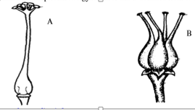

1. What name is given to; (2 marks)
   * 1. Gynoecium A

……………………………………………………………………………………………

* + 1. Gynoecium B

……………………………………………………………………………………………

* 1. State one observable difference between the two gynoecia. (1 mark)

………………………………………………………………………………………………………………………………………………………………………………………………………………………………………………………………………………………………

1. Name one enzyme that is secreted in its precursor form. (1 mark)

………………………………………………………………………………………………….

1. State two reasons why the stomach lining is not usually digested by pepsin though the lining is made of protein. (2 marks)

..................................................................................................................................................................................................................................................................................................................................................................................................................................................................

1. Explain how predators can influence natural selection (2 marks)

…………………………………………………………………………………………………………………………………………………………………………………………………………………………………………………………………………………………………………………………………………………………………………………………………………

1. The diameter of the field of view of a light microscopic is 6.5 mm. Plant cells lying across the diameter are 12.

Determine the size of one cell in micrometers. (2 marks)

* 1. Explain how drooping of leaves on a hot sunny day is advantageous to a plant. (2 marks)

………………………………………………………………………………………………………………………………………………………………………………………………

* 1. A strip of peeled potato whose cell sap concentration was 30% was placed in a petri-dish containing 10% sugar solution.

Account for the observation made after minutes. (2 marks) ………………………………………………………………………………………………………………………………………………………………………………………………………………………………………………………………………………………………

* 1. What causes diabetes insipidus (1 mark)

……………………………………………………………………………………………..

* 1. A doctor suspects that their patient has diabetes mellitus. How can this be determined in a school laboratory (2 marks)

………………………………………………………………………………………………………………………………………………………………………………………………………………………………………………………………………………………………………………………………………………………………………………………………………………………………………………………………………………………………

* 1. Explain why specimens are collected and preserved in specimen bottles. (1 mark) ………………………………………………………………………………………………………………………………………………………………………………………………
  2. What is binomial nomenclature as used in the naming of living organisms? (1 mark) ………………………………………………………………………………………………………………………………………………………………………………………………
  3. Give a reason why scientific names are given in Latin. (1 mark) ………………………………………………………………………………………………………………………………………………………………………………………………

1. Draw a well labelled diagram of a root hair cell (3 marks)
2. 1. What is meant by the term gaseous exchange? (1 mark) ………………………………………………………………………………………………………………………………………………………………………………………………
   2. Explain why respiratory surfaces are moist. (1 mark) ………………………………………………………………………………………………………………………………………………………………………………………………
3. An organism was found to have a dental formula.

i 0/3 c0/1 pm3/2 m3/3 = 30

1. State the mode of feeding of the organism (1 mark)

………………………………………………………………………………………………

1. Give a reason for your answer in (a) above. (1 mark)

…………………………………………………………………………………...…………

………………………………………………………………………………………………

1. What is the meaning of each of the following terms (2 marks)
   1. Homeostasis

………………………………………………………………………………………………………………………………………………………………………………………………………………………………………………………………………………………………

* 1. Osmoregulation

……………………………………………………………………………………………………………............................................................................................................................................................................................................................................................................

* 1. Name the hormones involved in regulation of glucose level in the blood (2 marks) ………………………………………………………………………………………………….…………………………………………………………………………………………...

1. State two structural differences between ribonucleic acid (RNA) and deoxyribonucleic acid (DNA). (2 marks)

………………………………………………………………………………………………………………………………………………………………………………………………………………………………………………………………………………………………………………………………………………………………………………………………………….

1. The diagram below represents a tissue obtained from a mammal.

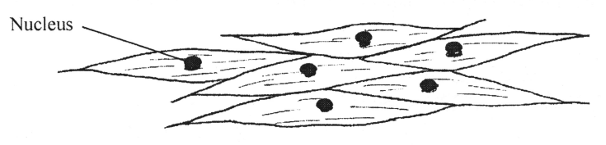

1. Identify the tissue (1 mark)

…………………………………………………………………………………………….

1. Name one organ in which the above tissue is found. (1 mark)

………………………………………………………………………………………………………………………………………………………………………………………………

1. State two adaptations of the tissue to its function. (2 marks)

………………………………………………………………………………………………………………………………………………………………………………………………………………………………………………………………………………………………………………………………………………………………………………………………

1. The following is an equation representing a type of respiration.

C6H12O6 2C3H6O3 + ATP

* 1. Identify the type of respiration. (1 mark)

................................................................................................................................................

* 1. Suggest one industrial application of the process named in (a) above. (1 mark)

................................................................................................................................................................................................................................................................................................

1. Name any one physiological process in plants that may be affected by dust as a pollutant.

(1 mark)

……………………………………………………………………………………………………………………………..……………………………………………………………………..

1. 1. Name the causative agent for amoebic dysentery. (1 mark)

………………………………………………………………………………………………

* 1. State two preventive measures of schistosomiasis in human beings (2 marks)

……………………………………………………………………………………………………………….……………………………………………………………………………..………………………………………………………………………………………………

1. State how pollution from the following pollutants can be controlled.
   1. Oil spillage (1 mark)

………………………………………………………………………………………………………………………………………………………………………………………………

* 1. Industrial effluents (1 mark)

………………………………………………………………………………………………………………………………………………………………………………………………

* 1. Inorganic fertilizers (1 mark)

………………………………………………………………………………………………………………………………………………………………………………………………

1. The figure below represents a unicellular organism.

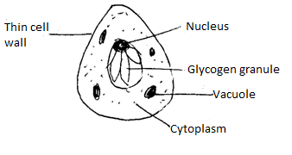

* 1. State the mode of nutrition exhibited by the organism (1 mark)

…………………………………………………………………..…………………………

* 1. Name the kingdom to which it belongs (1 mark)

………………………………………………………………………………………………

* 1. State one feature common to members of the kingdom named in (b) above. (1 mark)

………………………………………………………………………………………………………………………………………………………………………………………………

* 1. Name the part of an enzyme where substrate molecules fix themselves during an enzyme catalyzed reaction (1 mark)

………………………………………………………………………………………………

* 1. State what would happen to an enzyme if the temperature is
     1. Raised above optimum (1 mark)

…………………………………………………………………………………………………………………………………………………………………………………………

* + 1. Lowered below 100C (1 mark)

…………………………………………………………………………………………………………………………………………………………………………………………

* 1. What is seed dormancy? (1 mark)

…………………………………………………………………………………...…………………………….…………………………………………………………………………..

* 1. Name a growth inhibitor in seeds (1 mark)

………………………………………………………………………………………………

1. The diagram below shows a phenomenon which occurs during cell division.

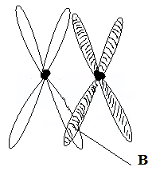

* 1. Identify the stage of cell division in which this phenomenon occurs. (1 mark)

……………………………………………………………………………………………

* 1. State the importance of the phenomenon-taking place in the part labeled B. (2 marks)

……………………………………………….…..…………………………………………………………….……………………………………………………………………………………………………………………………………………………………………….

* 1. What is meant by the term Genetically Modified Organism (GMO)? (1 mark)

………………………………………………………………………………………………………………………………………………………………………………………………………………………………………………………………………………………………

* 1. Name one area in Medicine where knowledge of Genetic Engineering has been successfully applied. (1 mark)

………………………………………………………………………………………………………………………………………………………………………………………………

1. The illustration below shows a transverse section through a mammalian kidney.

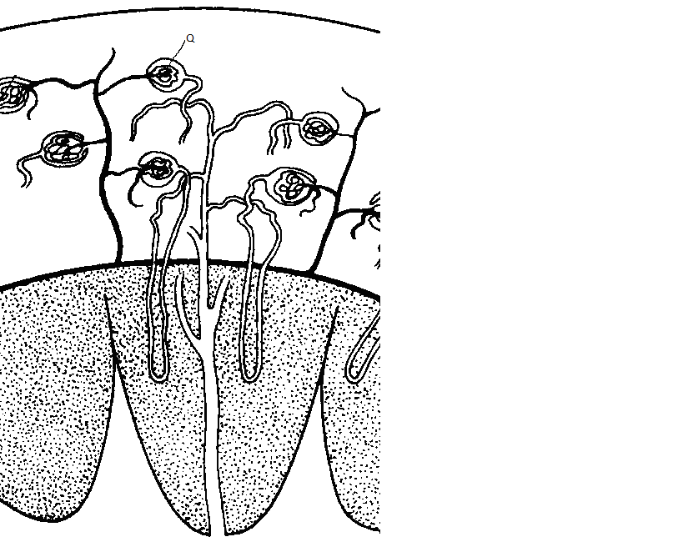

**Y**

**X**

* 1. Name the structures labelled X and Y. (2 marks)

X…………………………………………………………………………………………. Y………………………………………………………………………………………….

* 1. State the process in Q that leads to the formation of glomerular filtrate. (1 mark)

………………………………………………………………………………………………

………………………..……………………………………………………………………

1. The diagram below shows one of the cell organelles.

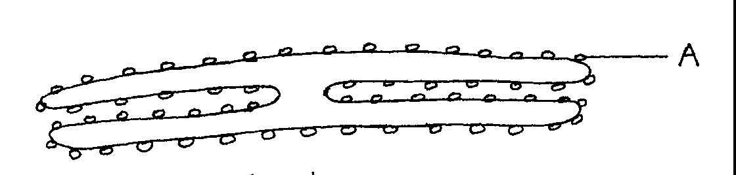

* 1. Identify the organelle (1 mark)

………………………………………………………………………………………………

* 1. Give the function of the part of the organelle marked A. (1 mark)

………………………………………………………………………………………………………………………………………………………………………………………………

1. State two characteristics of meristematic cells. (2 marks)

………………………..……………………………………………………………………………………….……………………………………………………………………………………

………………………..…………………………………………………………………………………………………..…………………………………………………………………………

1. During a study, 48 larvae were put in unpainted side of the petri dish as shown below.

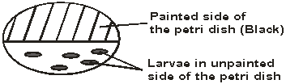

The Petri-dish was left in bright sunshine, the number of larvae on unpainted side was counted every minute for five minutes, and the results obtained were as shown below.

|  |  |  |
| --- | --- | --- |
| Time (min) | Number of larvae | |
| In painted side | In unpainted side |
| 0 | 25 | 25 |
| 1 | 30 | 20 |
| 2 | 36 | 14 |
| 3 | 45 | 5 |
| 4 | 49 | 1 |
| 5 | 48 | 0 |

1. What conclusion can you draw from these results about the behaviour of the larvae?

(1 mark)

…………………………………………………………………………………………..

1. Name the response exhibited by the larvae. (1 mark)

…………………………………………………………………………………………….

1. What is the survival value of this behaviour to the larvae? (2 marks)

………………………………………………………………………………………………………………………………………………………………………………………………………………………………………………………………………………………………